# Week_4

1. **Handson_1 :-First Web Api using .Net core**

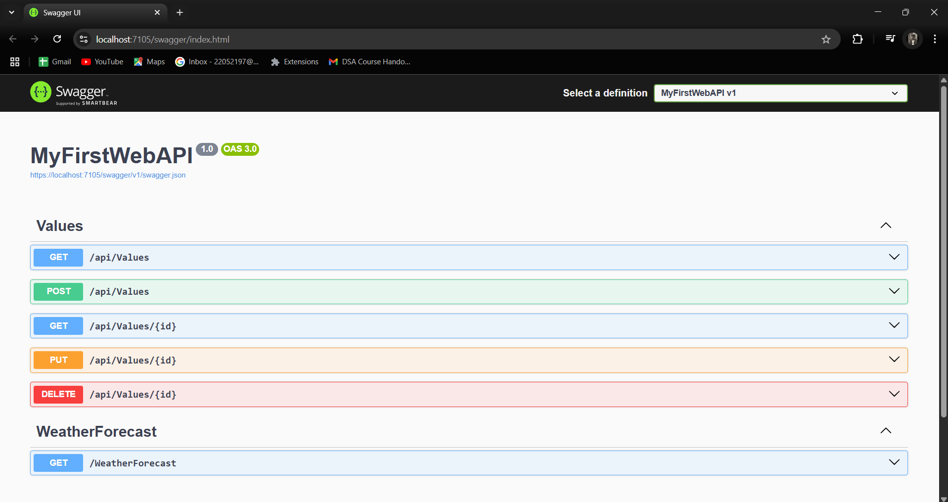

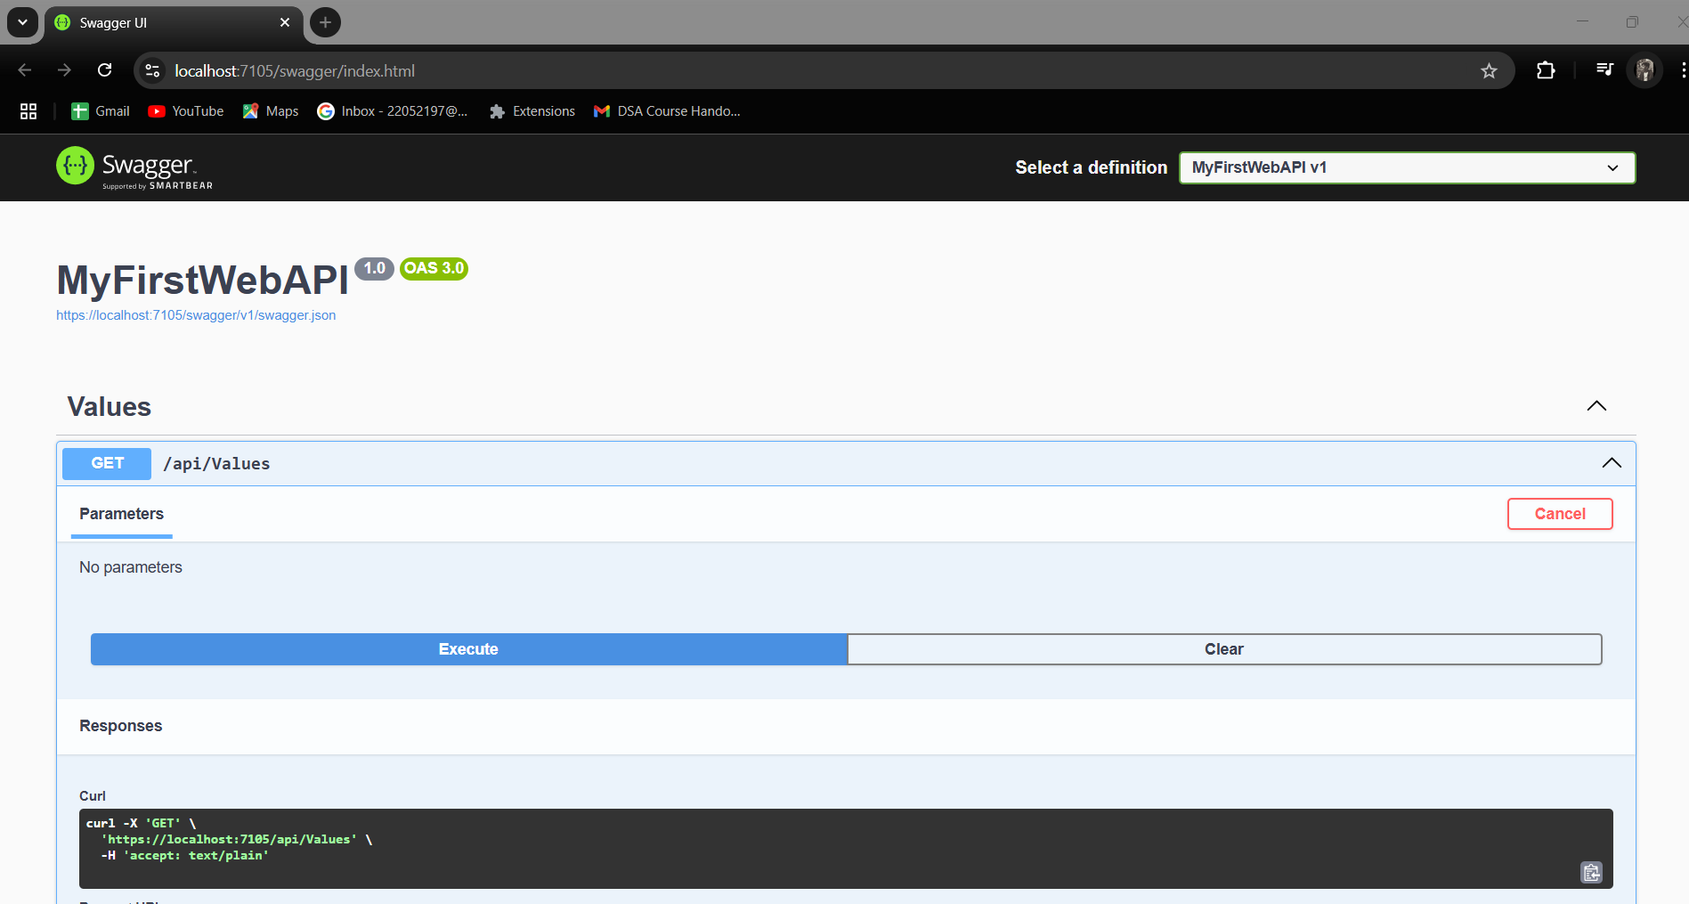

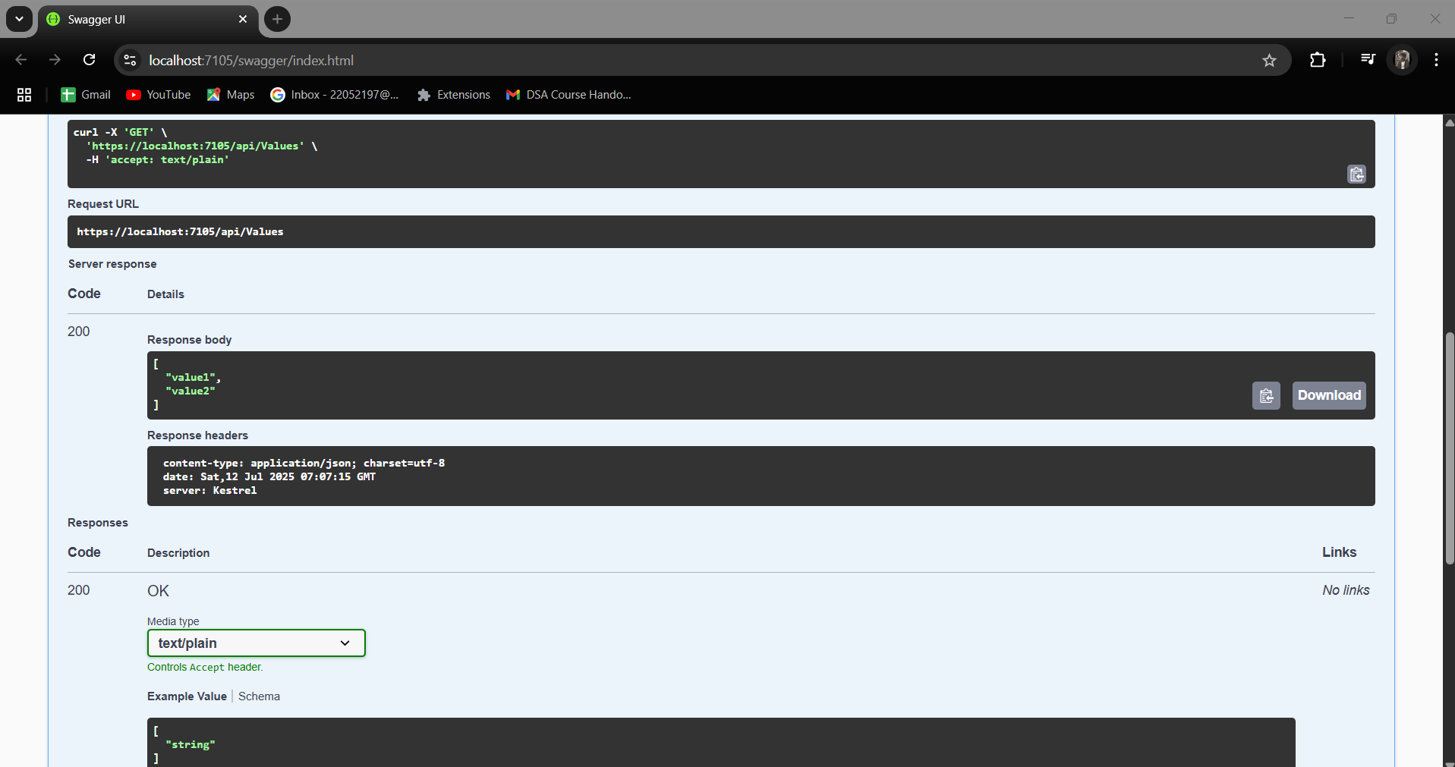

1. **Handson_2**

**1)Web Api using .Net core with Swagger**

1. EmloyeeController.cs

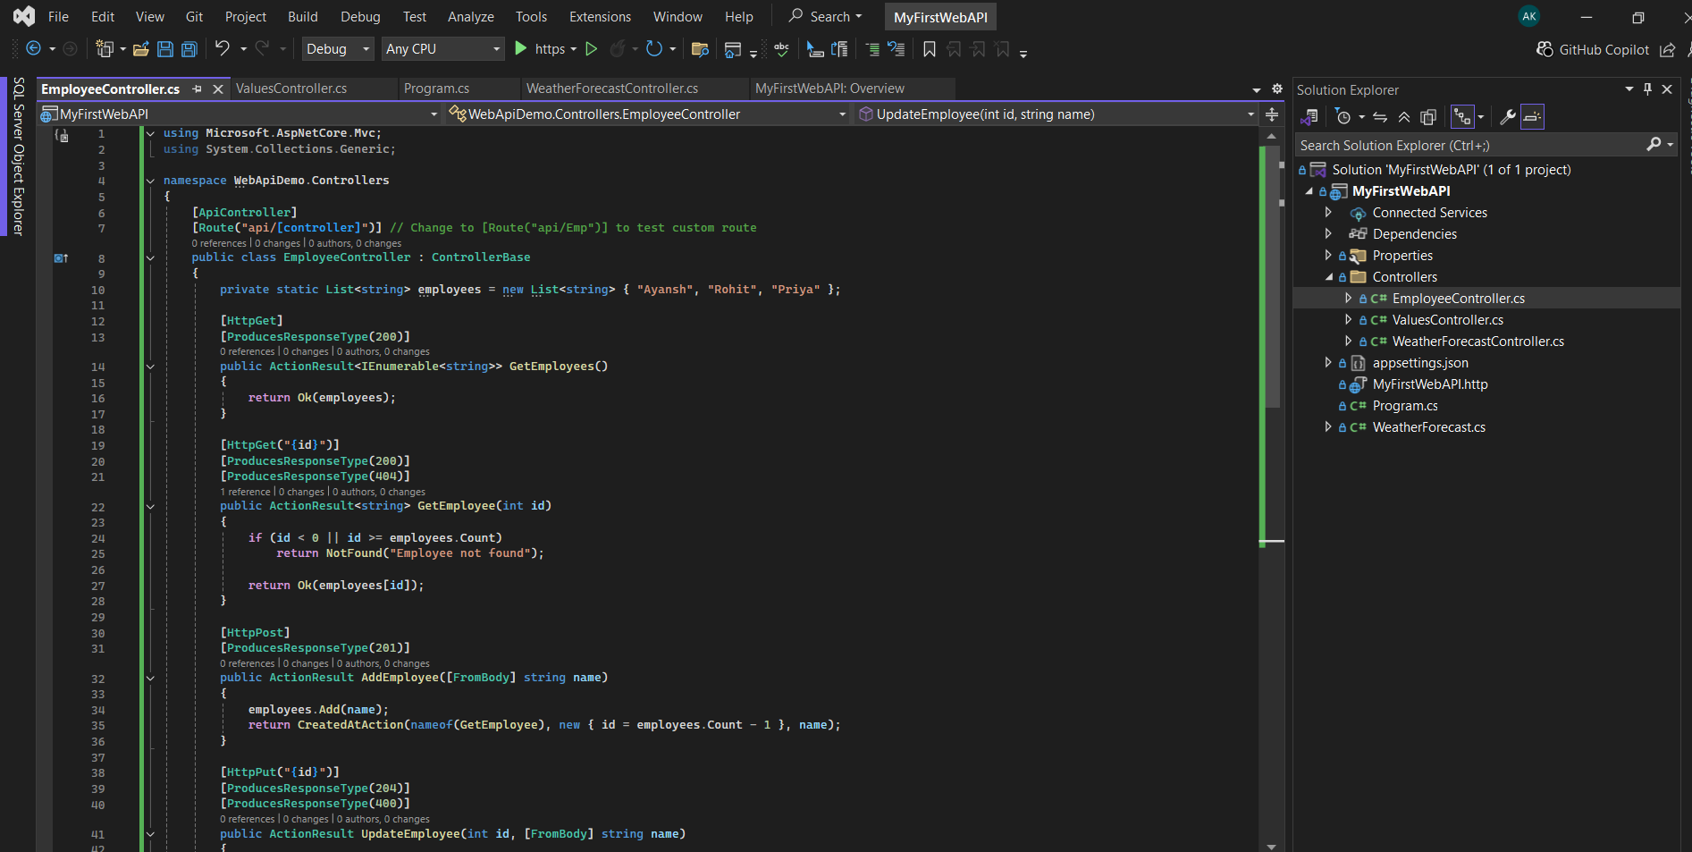

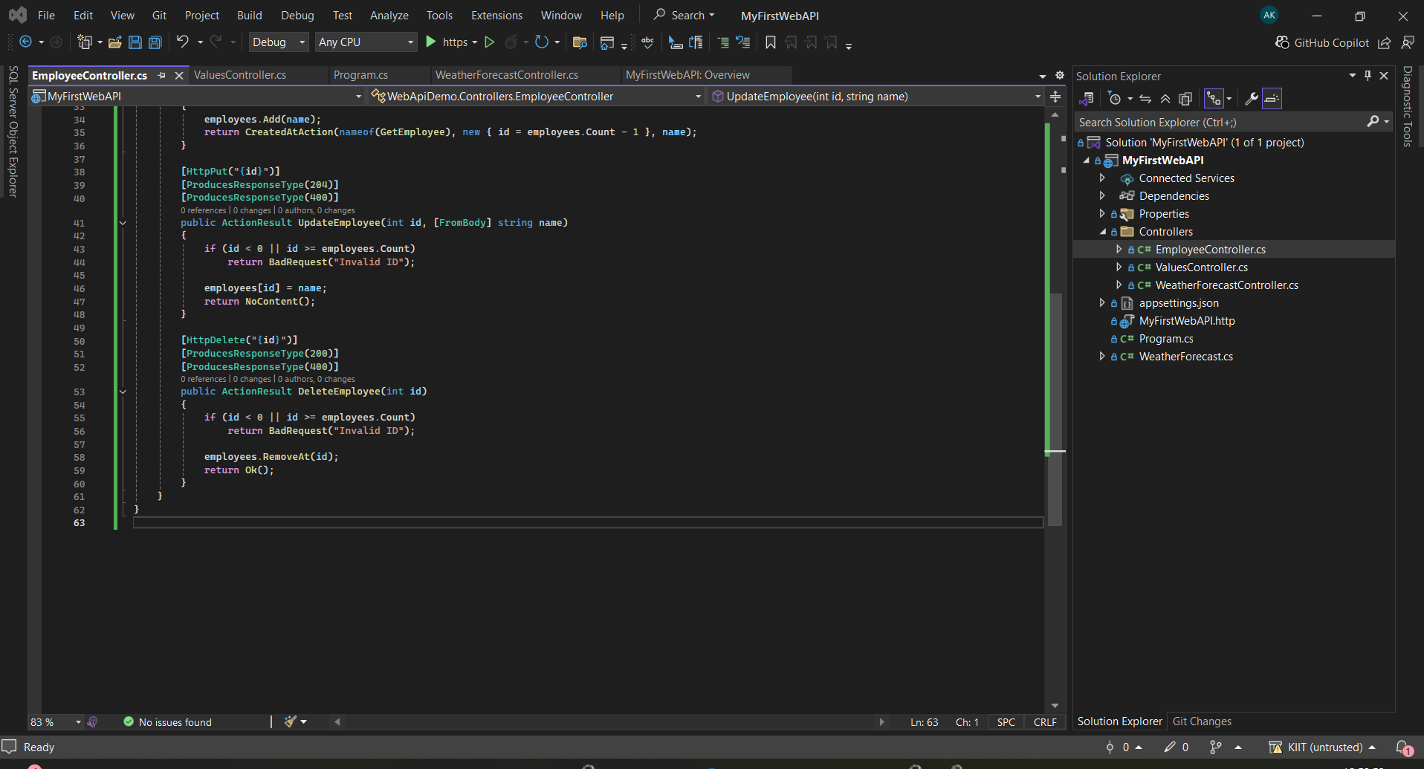

1. Updated Program.cs

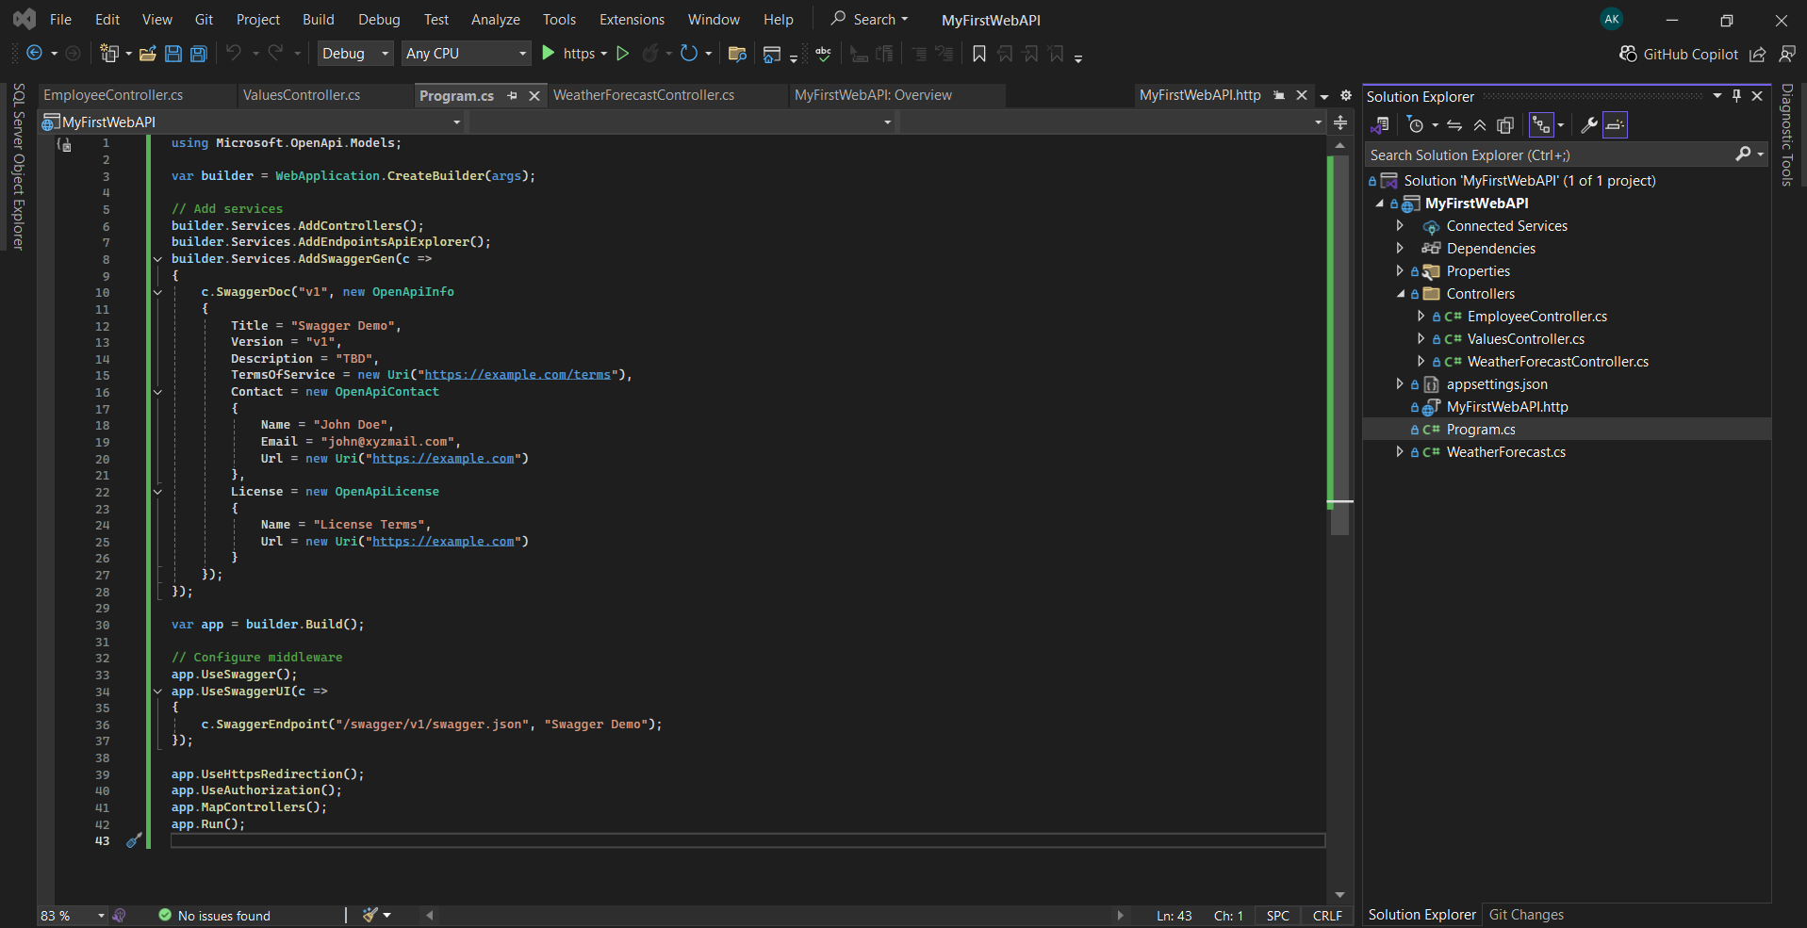

Output-

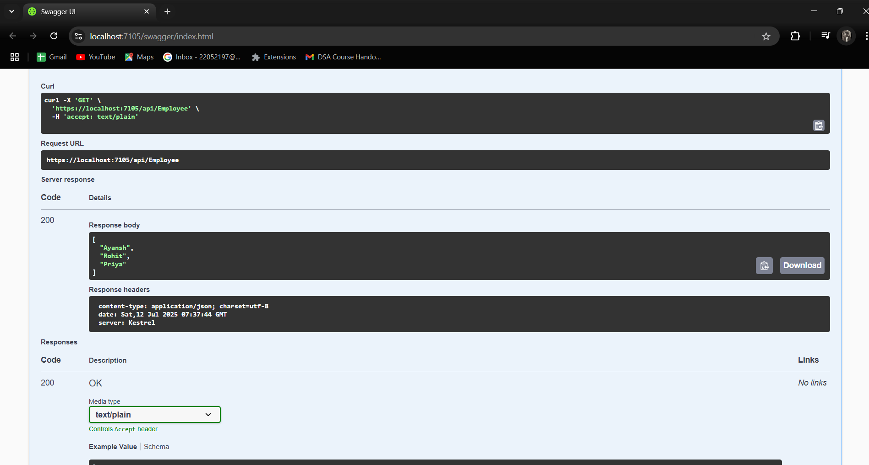

2)Use POSTMAN tool, to point to the local Web API that was created with Employee controller. Test the GET action method using POSTMAN.

Verify the output if the List of employees are listed in the ‘Body’ part of the GET window on POSTMAN tool.

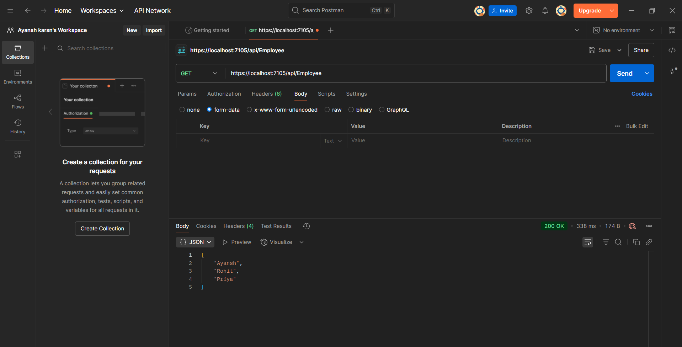

3)Modify the Controller name in the Route attribute of the Employee controller to ‘Emp’ and check its access thru POSTMAN

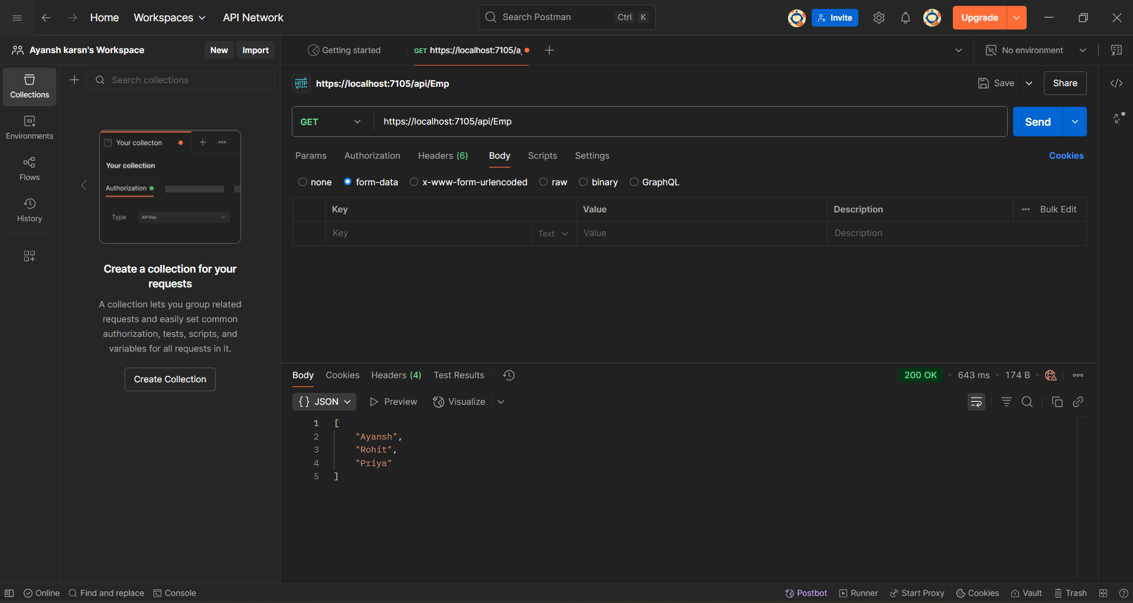

# 3.Handson_3

**1. Web Api using custom model class**

**A)Employee.cs**

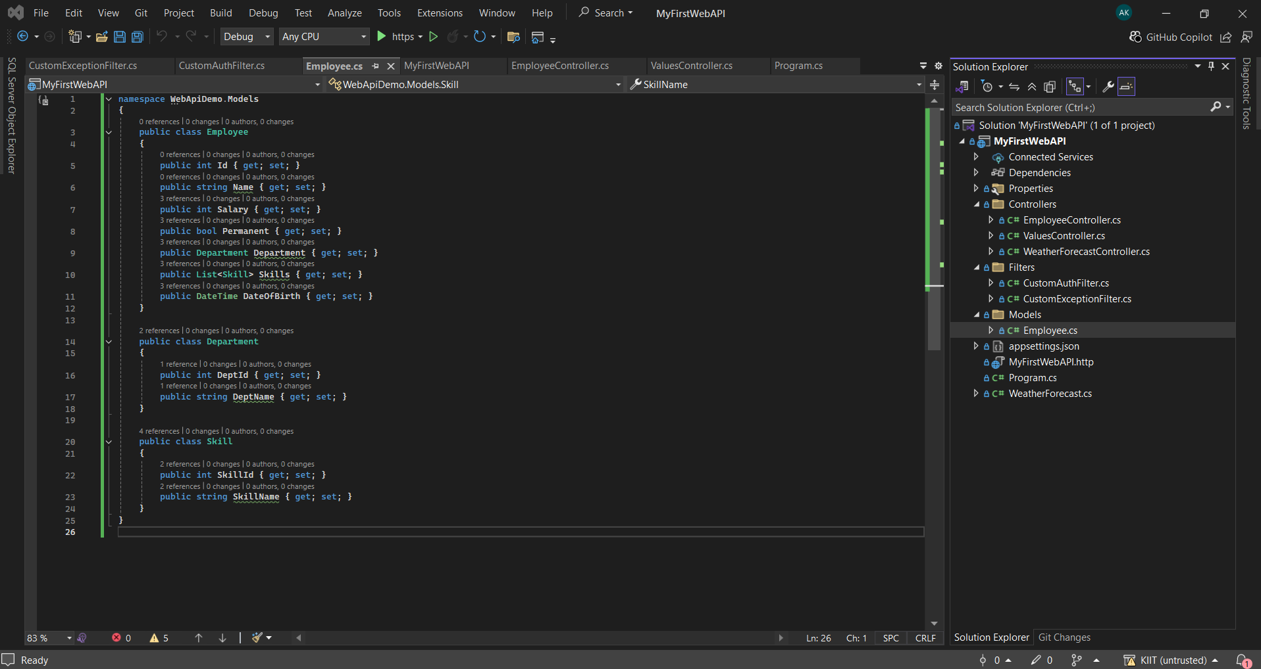

**B)EmployeeController.cs**

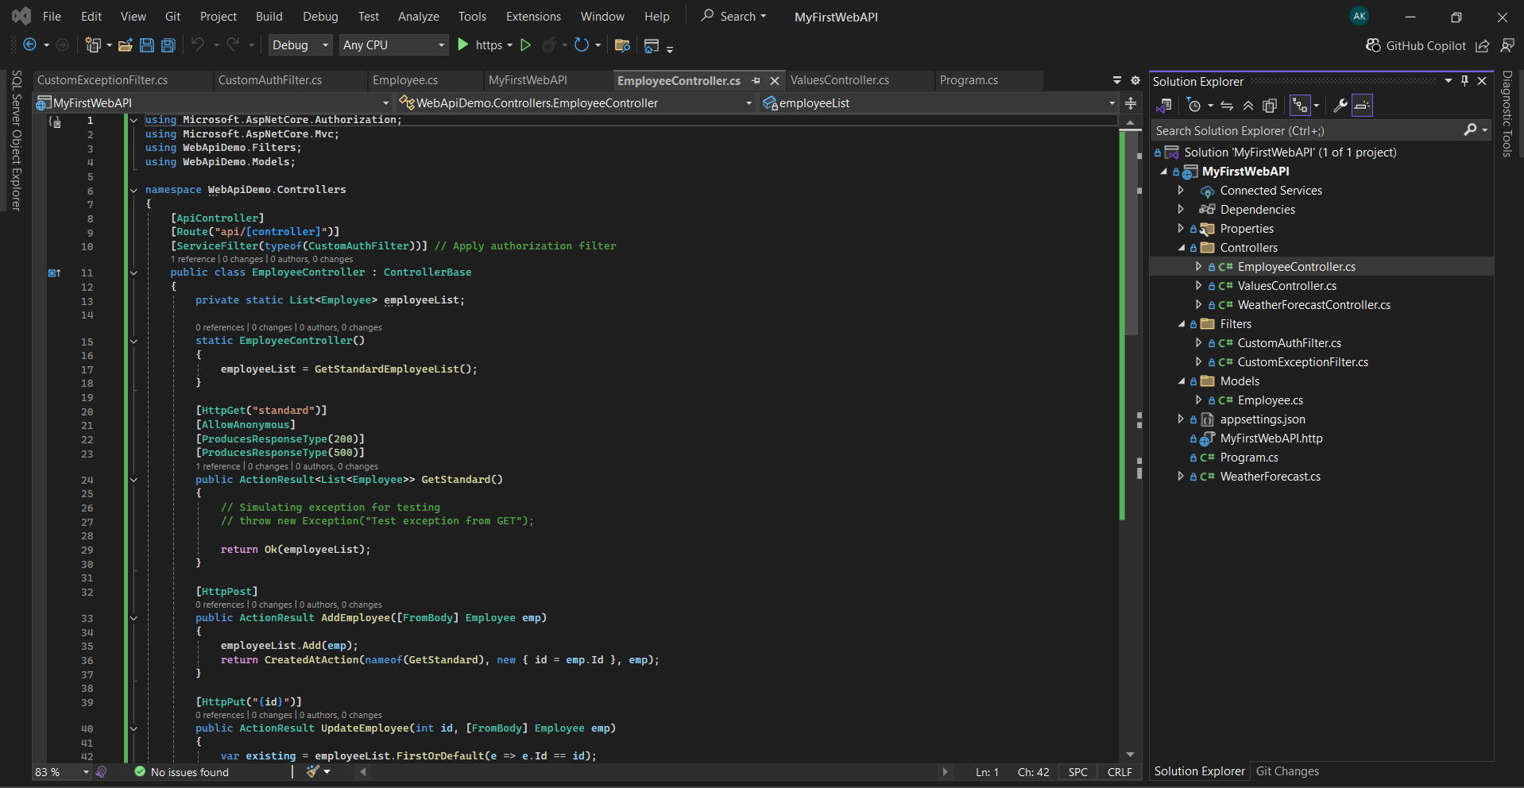

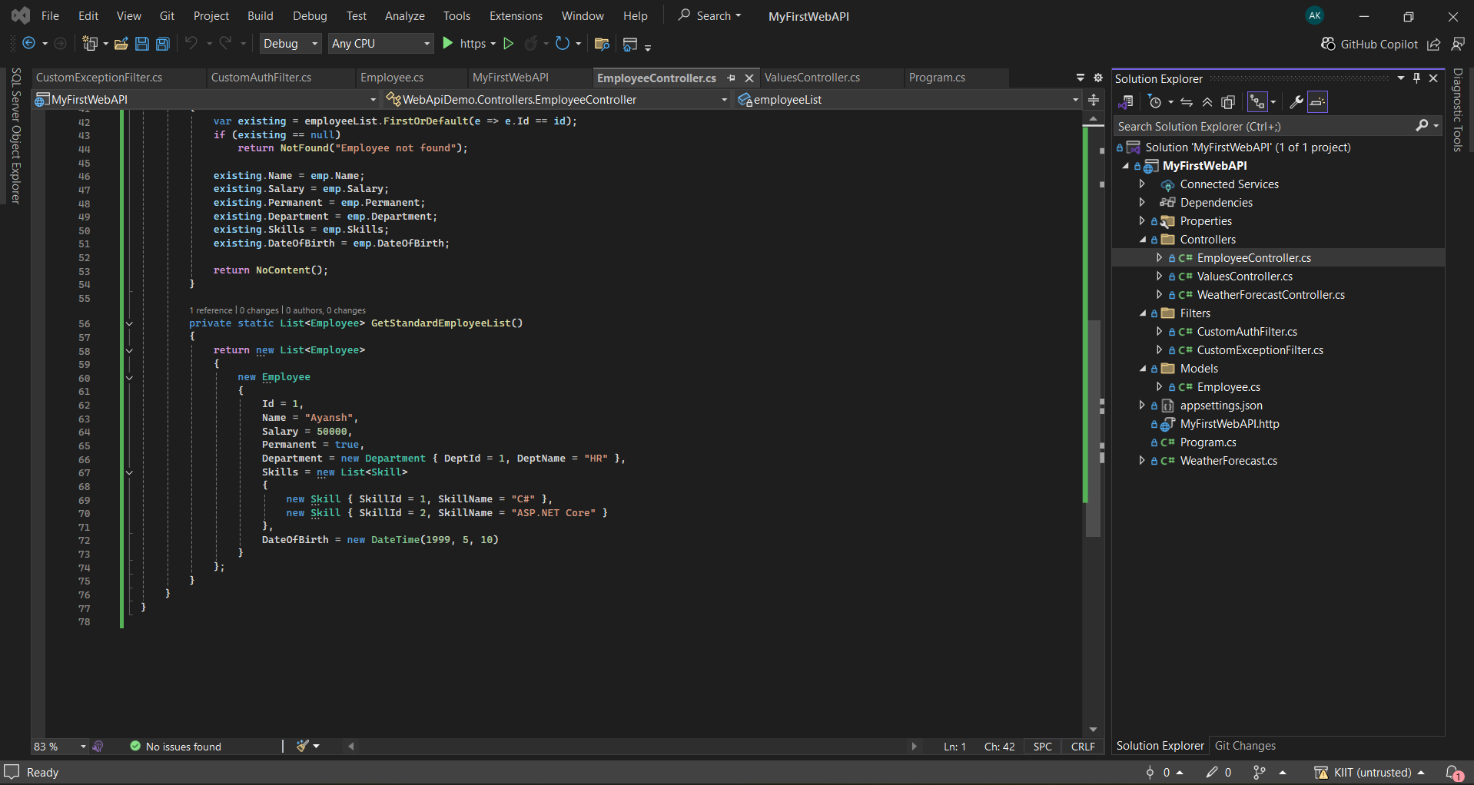

1. **CustomAuthFilter.cs**

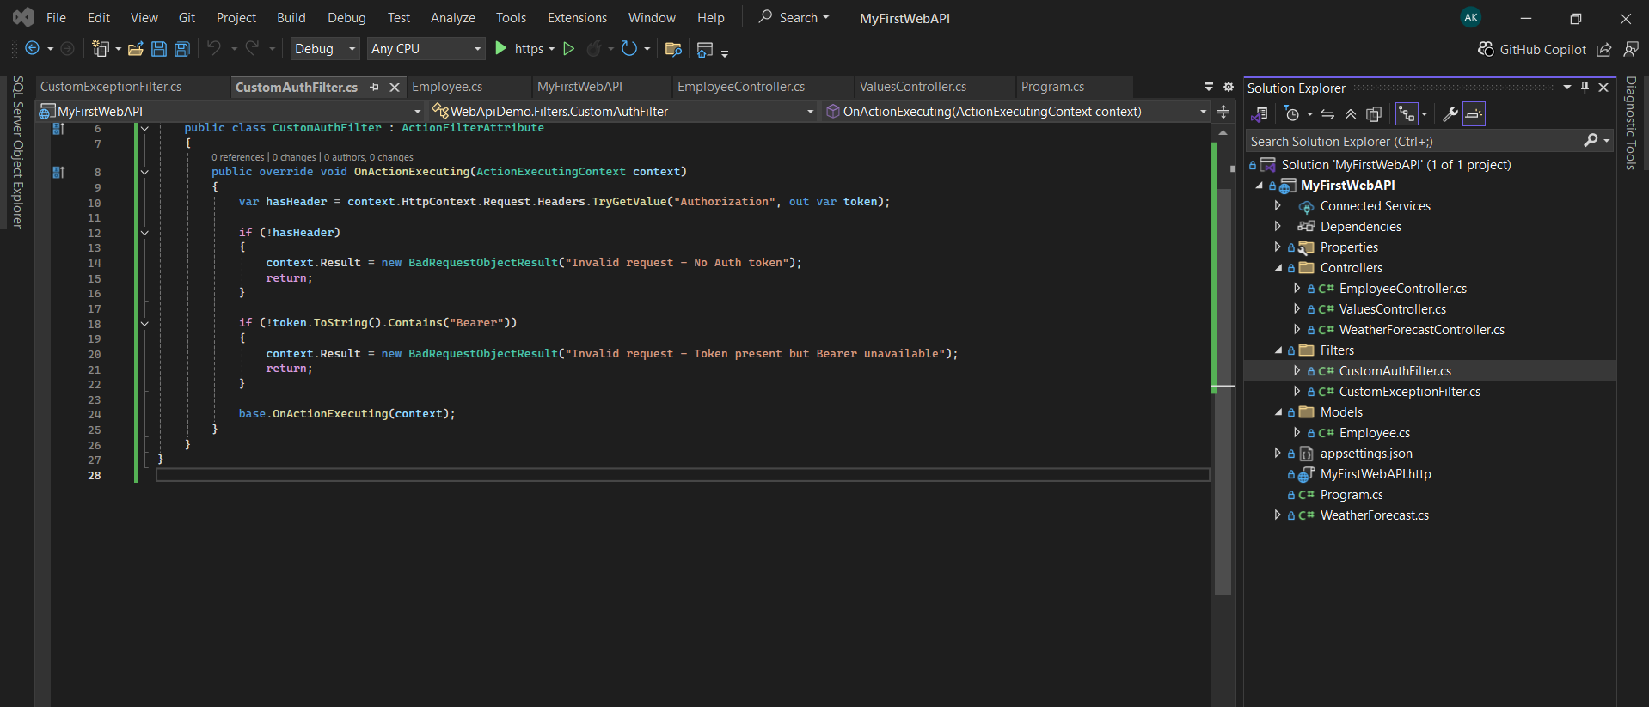

1. **CustomExceptionFilter.cs**

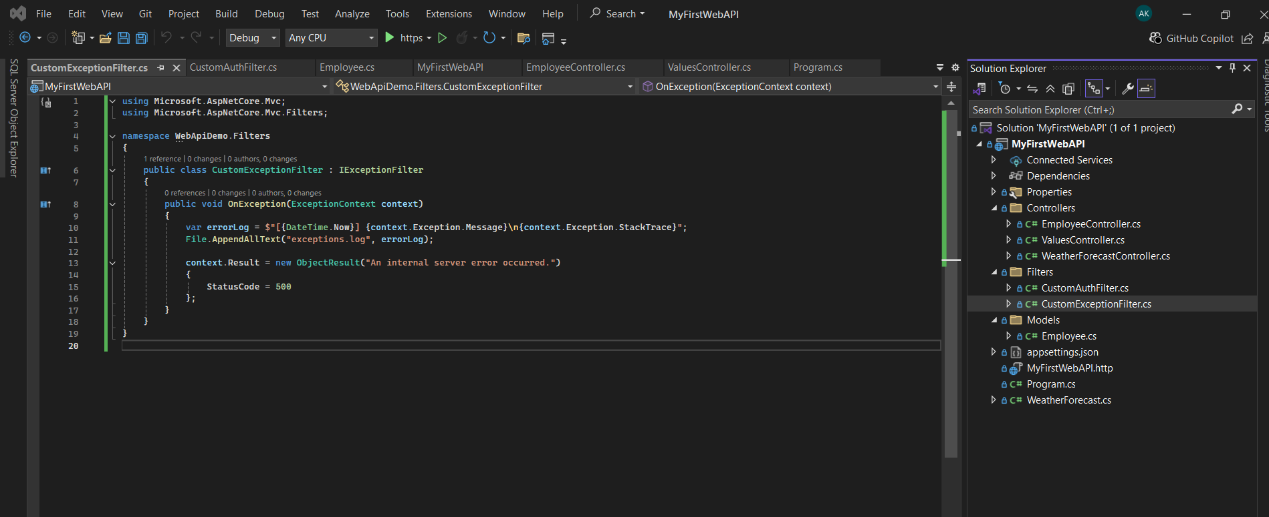

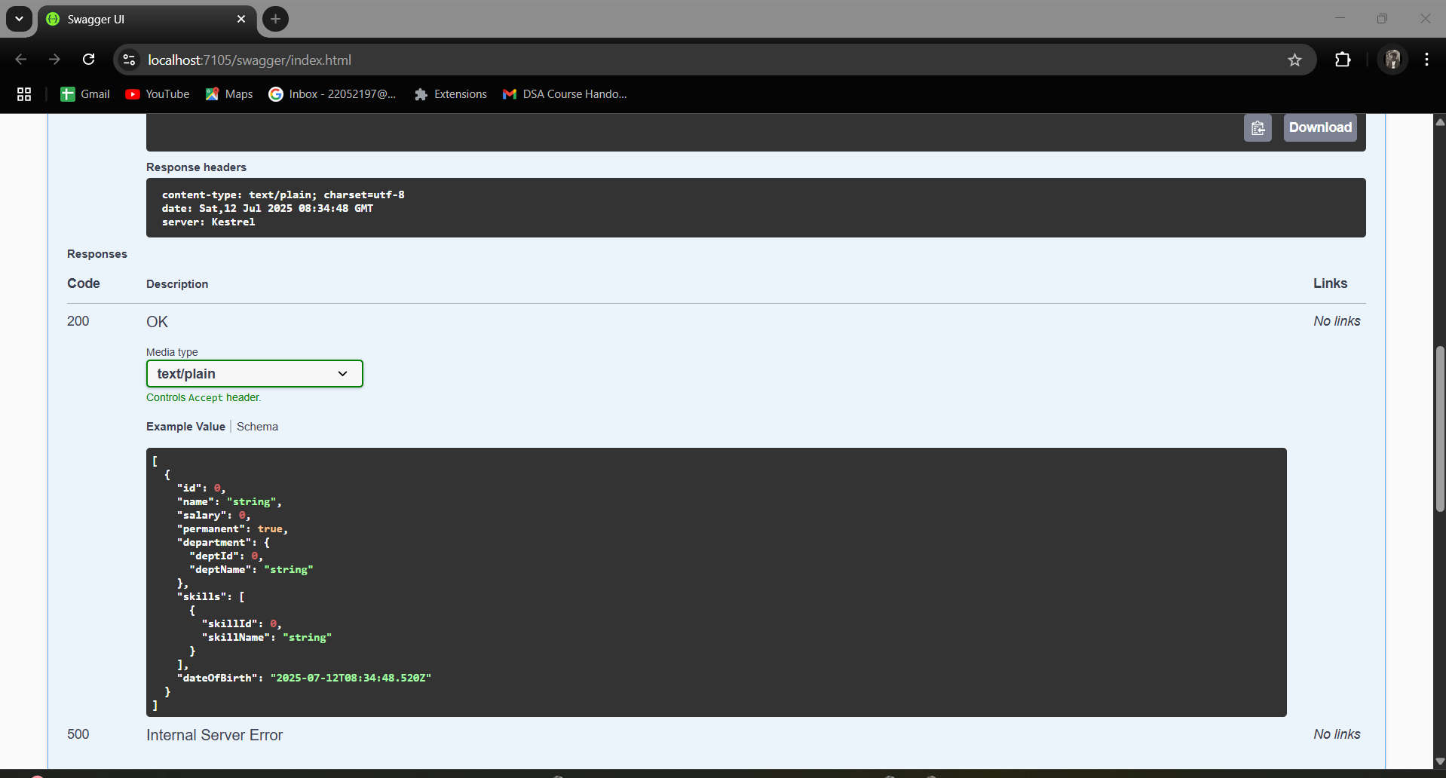

# 4.Handson_4

Updated EmployeeController

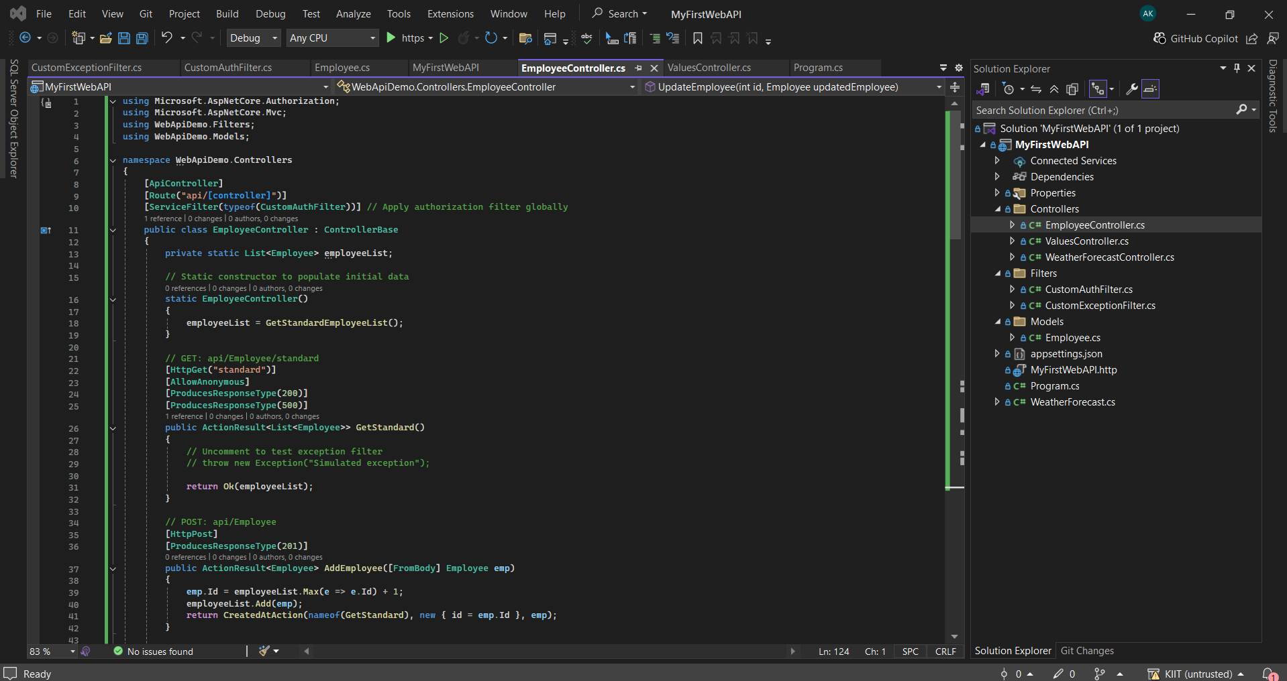

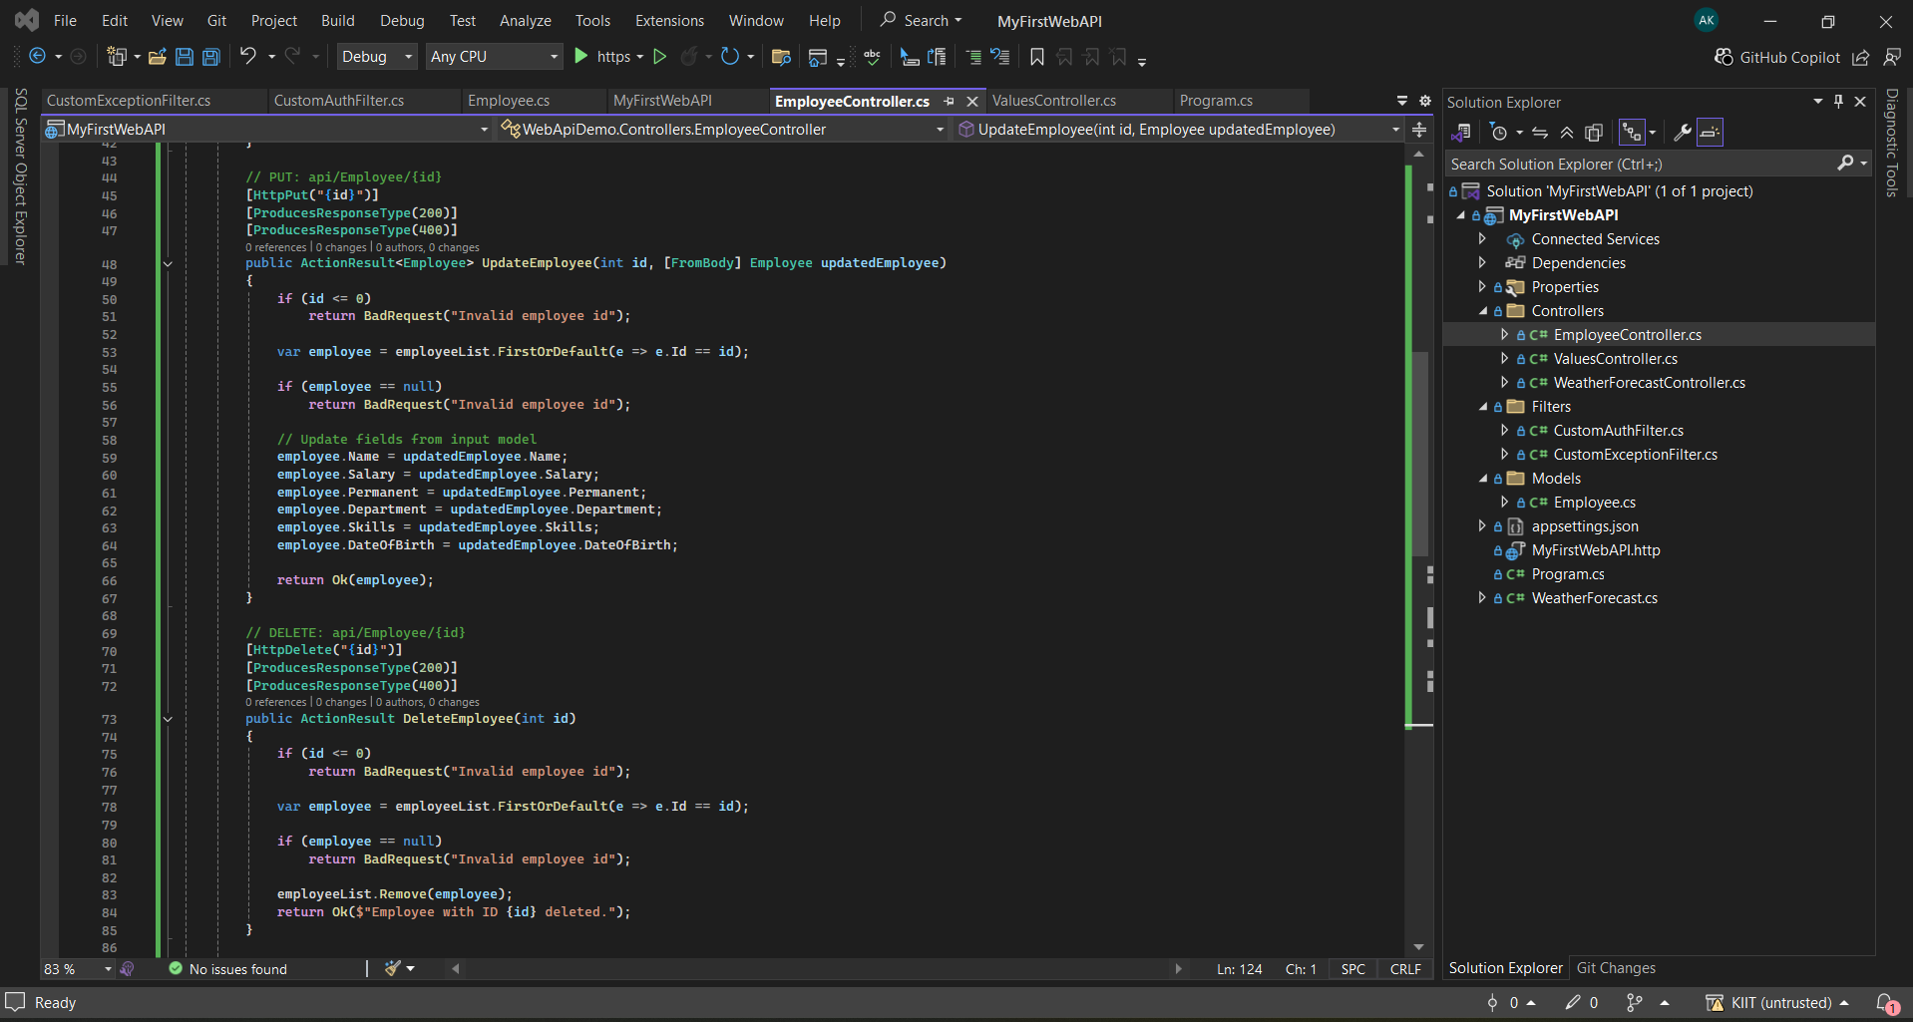

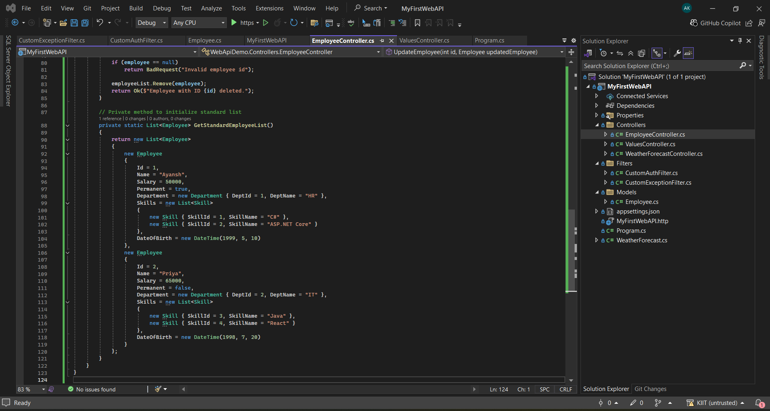

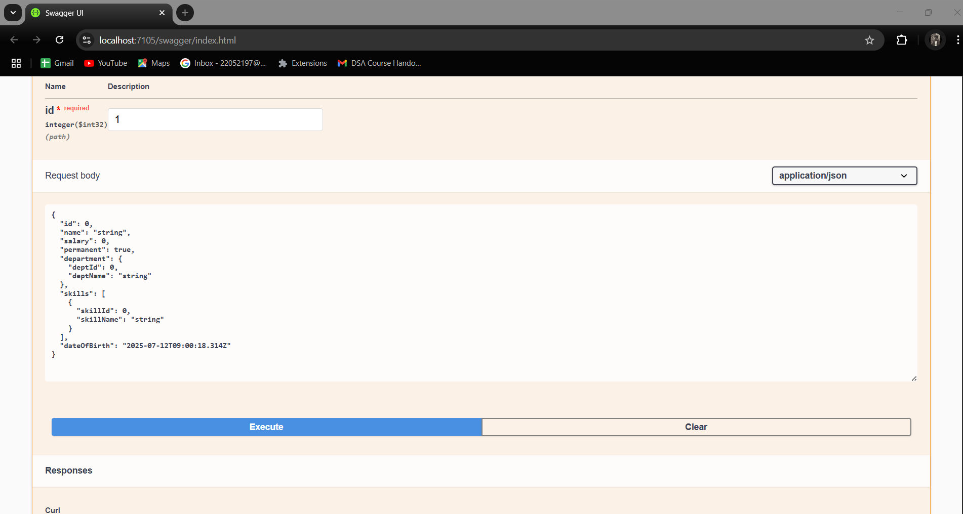

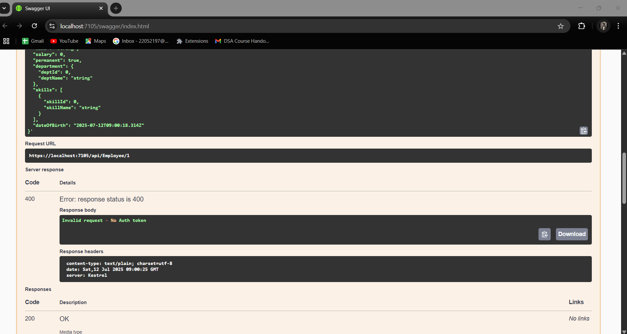

# handson_5

1. Updated Program.cs

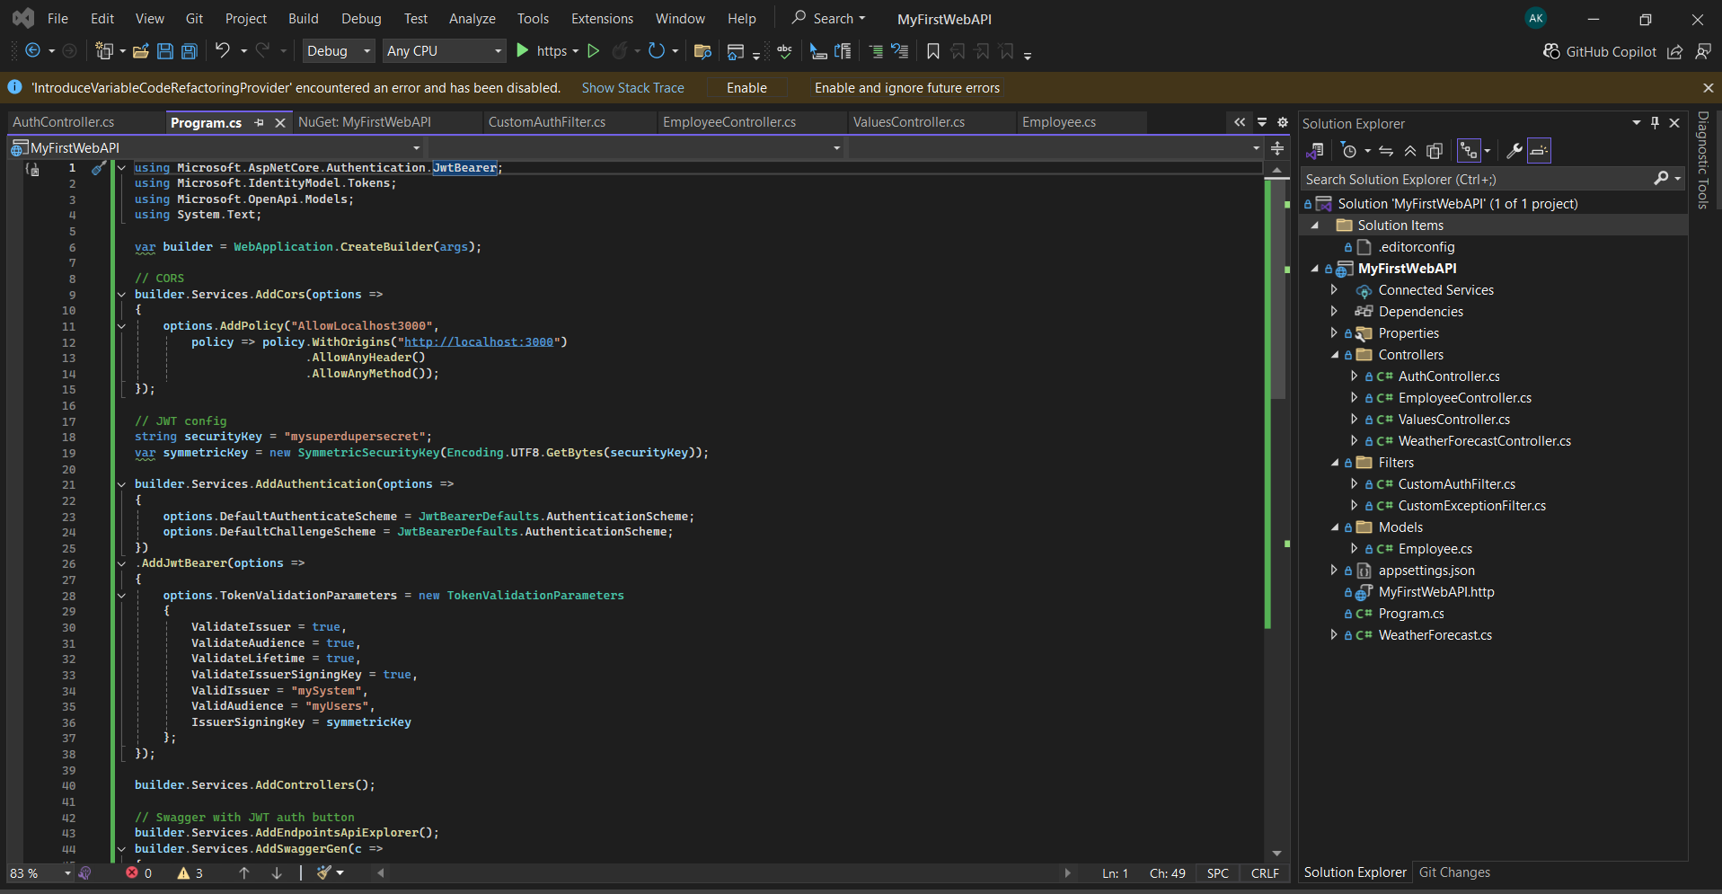

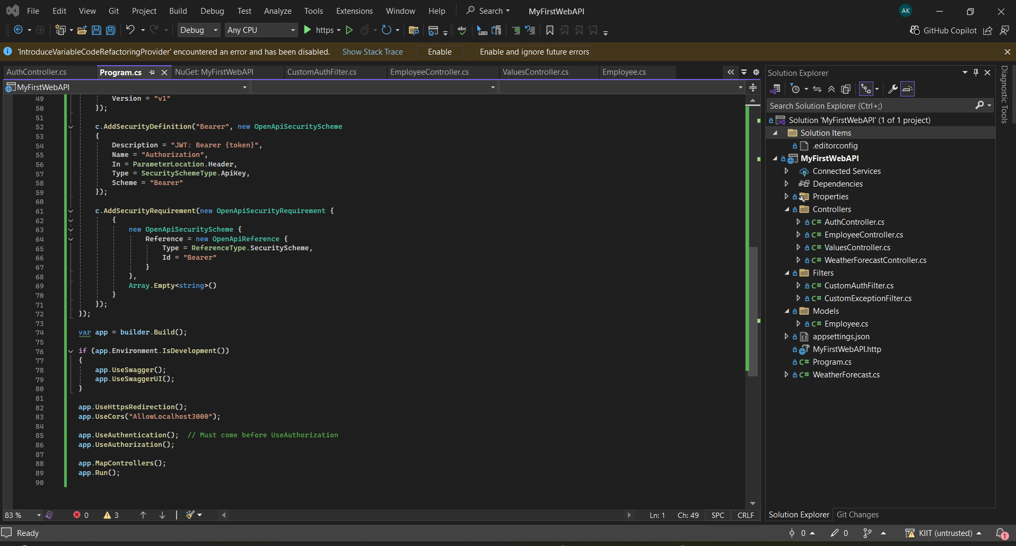

2)AuthController.cs

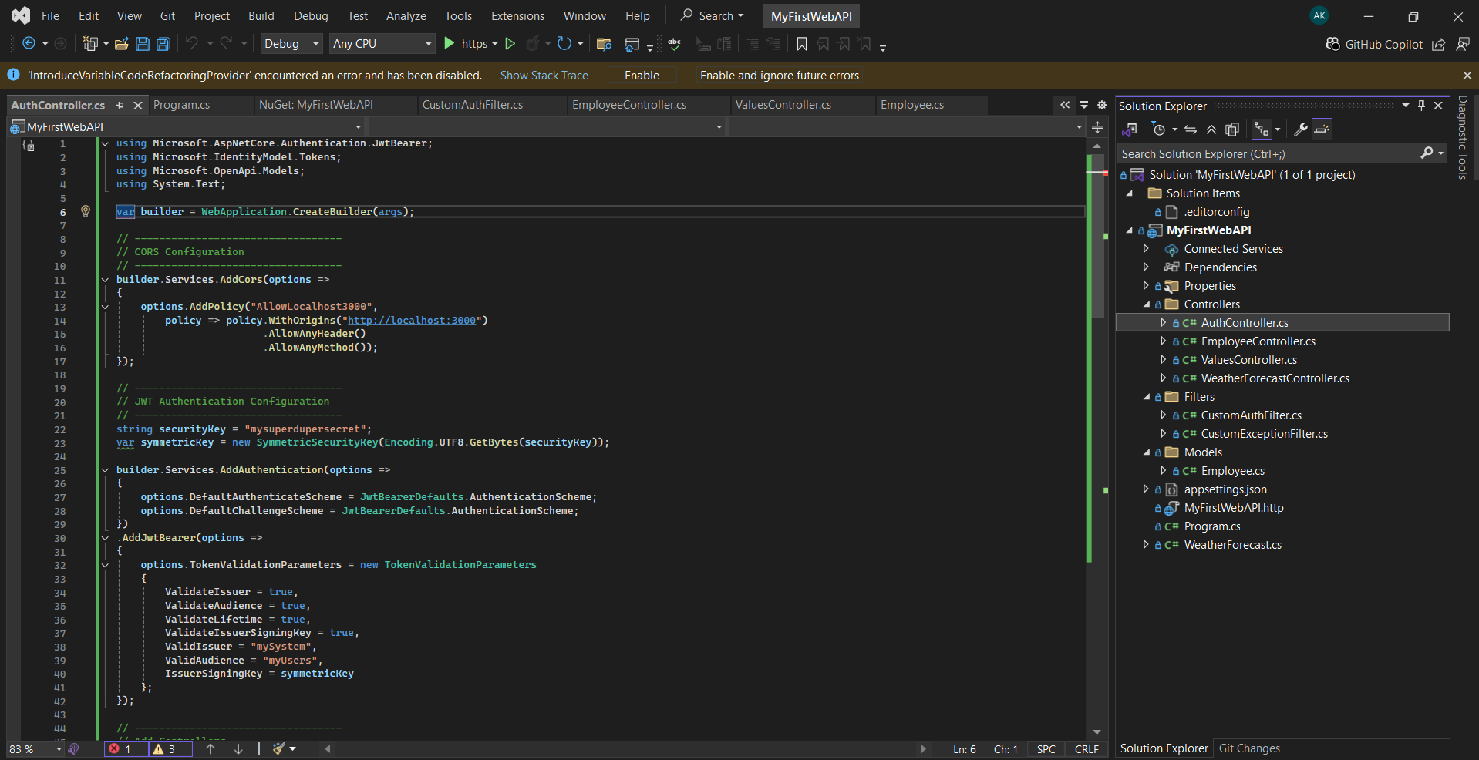

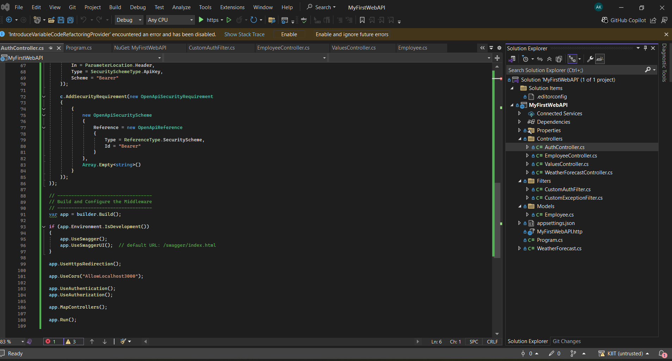

1. Updated EmployeeController.cs

